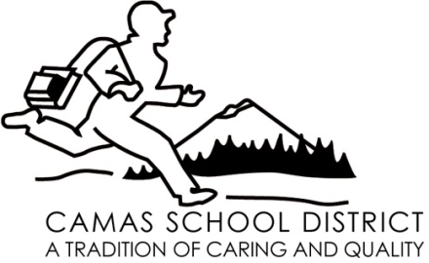

November 20, 2008

For additional information, contact:
Kathy Tomei, Nursing Supervisor
Camas School District
(360)833-5850, ext. 7414

FOR IMMEDIATE RELEASE

Camas School District seeks health committee members

The Camas School District is seeking eight individuals to serve on the district’s Student Health Advisory Council (SHAC). Ideally, the volunteers would have a background in comprehensive school health education, physical education, nutrition, a healthy school environment, health promotion for staff, or family and community experience. Specifically, SHAC is seeking parent, teacher, and community representation from the following schools: Lacamas Heights Elementary, J. D. Zellerbach Elementary, Prune Hill Elementary, Skyridge Middle School, Liberty Middle School, and Camas High School.

SHAC consists of about 20 school district stakeholders who advise school administrators and board members on a variety of health and fitness issues. Meetings are held once a month during the school year.

Interested citizens are encouraged to send a letter of interest, and resume to Kathy Tomei at 1919 NE Ione Street, Camas, WA 98607, or kathy.tomei@camas.wednet.edu by December 5, 2008.

--end--

